**Aim:**

To implement steepest descent optimization technique

**Theory:**

**Method of Steepest Descent**

The technique of steepest descent, also known as gradient descent, is a general iterative method for finding local minima of a function f. The idea is that given a current estimate xi, the gradient ∇f(xi)—or more precisely, its negative—gives the direction in which f is decreasing most rapidly.

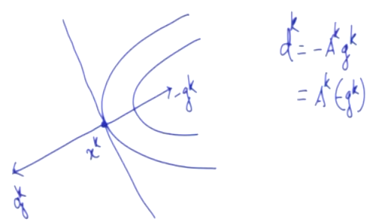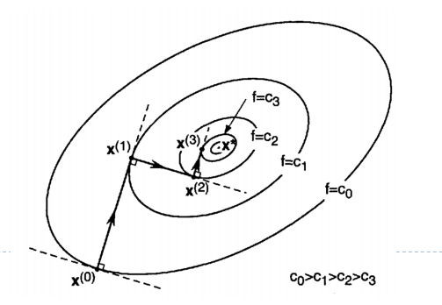

**Steepest Descent Method**

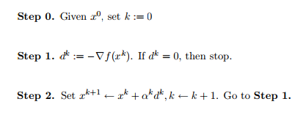

There are two methods for determining the learning rate αk . One approach is to minimize the performance index f(x) with respect to αk  at each iteration. In this case, the minimization is done along $x^{k}+α^{k}d^{k}$. The other method for selecting αk is to use a fixed value

**Experiment:**

Minimize

$$f\left(x\right)=x_{1}^{2}+25x_{2}^{2}$$

Given ${x^{0}}_{ }=\left[\begin{matrix}0.5 \\ 0.5\end{matrix}\right]$ and α = 0.01

Find any three similar optimization problem and solve it using steepest descent method

**Conclusion:** The implementation of steepest descent optimization was done.